

Front - End UI/UX Mini Project
Restaurant Launching Page

- Title Page

- Project Title: Restaurant Launching Page
- Submitted By:
  - 2462323 - Darren Samuel D’Cruz - darren.samuel@btech.christuniverityuniversity.in
  - 2462345 - P. Kamuel Shawn - p.kamuel@btech.christuniversity.in
  - 2462333 - Joel Jacob Roji - joel.jacob@btech.christuniversity.in
- Course: UI/UX Design Fundamentals
- Instructor Name: Mrs. Nagaveena
- Institution: Christ (Deemed – to – be) University
- Date of Submission: 12/08/2025

2. Abstract
The Luna Rossa Restaurant website is a responsive and visually appealing platform designed to showcase the restaurant’s offerings, history, and contact information. Built using HTML and CSS with no external JavaScript frameworks, the site aims to deliver a smooth and engaging user experience while maintaining fast load times.
3. Objectives
- Present the restaurant’s menu, history, and contact details in an organized manner.
- Implement a visually attractive design with strong branding.
- Ensure responsive layout across various devices like desktop, tablet, and mobile devices.
- Enable smooth navigation using anchor-based scrolling.
- Use lightweight code to enhance performance and accessibility.

4. Scope of the Project
- Complete front-end landing page for restaurant.
- No JavaScript or server-side integration
- Intended for desktop, tablet, and mobile viewports
- Used only open-source tools and pure code (no libraries) to ensure full customization, transparency and easy maintenance.

5. Tools & Technologies Used
Tool/Technology | Purpose
HTML5 | Markup and content structure
CSS3 | Styling and layout management
VS Code | Code editor
Google Fonts | For typography styling

6. HTML Structure Overview
- Used semantic tags: <header>, <nav>, <main>, <section>, <footer>
- Structured into reusable sections: Hero, Menu, About, Contact.
- Navigation menu created using <ul> and anchor links for smooth scrolling.

7. CSS Styling Strategy
- Used external CSS file (style5.css)
- Organized with comments and sections
- Techniques used:
  - Flexbox and CSS grid for responsive content arrangement.
  - Typography font for a modern look.
  - CSS Variables for theme customization.
  - Hover effects to increase interactivity.
  - Warm earthly color palette tones for an Italian feel

8. Key Features

Feature | Description
Responsive Design | Adapts seamlessly to all screen sizes
Smooth Navigation | Fixed top nav with anchor links
Project Cards | Flex-based layout with hover effects
Food Gallery | To attract and capture customers
Accessible Fonts & Colors | High contrast and readable typography

9. Challenges Faced & Solutions
Challenge | Solution
Overlapping elements on small screens | Implemented responsive design techniques, like flex-wrap and media queries
Ensuring images maintained aspect ratio without stretching | Used ‘object-fit: cover’ in CSS for consistent image presentation
Maintaining navigation clarity on mobile devices | Implemented a hamburger menu for small screens

10. Outcome
- Successfully built a clean, professional, and fully responsive restaurant website
- Improved accessibility and user experience with optimized layout and navigation
- All key components function as intended using just HTML and CSS
- Learned about layout responsiveness and UI hierarchy in depth

11. Future Enhancements
- Add JavaScript for interactivity (form validation, dynamic content)
- Add an actual interactive Google Map in the contact section
- Integrate online table reservation functionality
- Implement backend support for newsletter subscriptions

12. Sample Code

- HTML code:
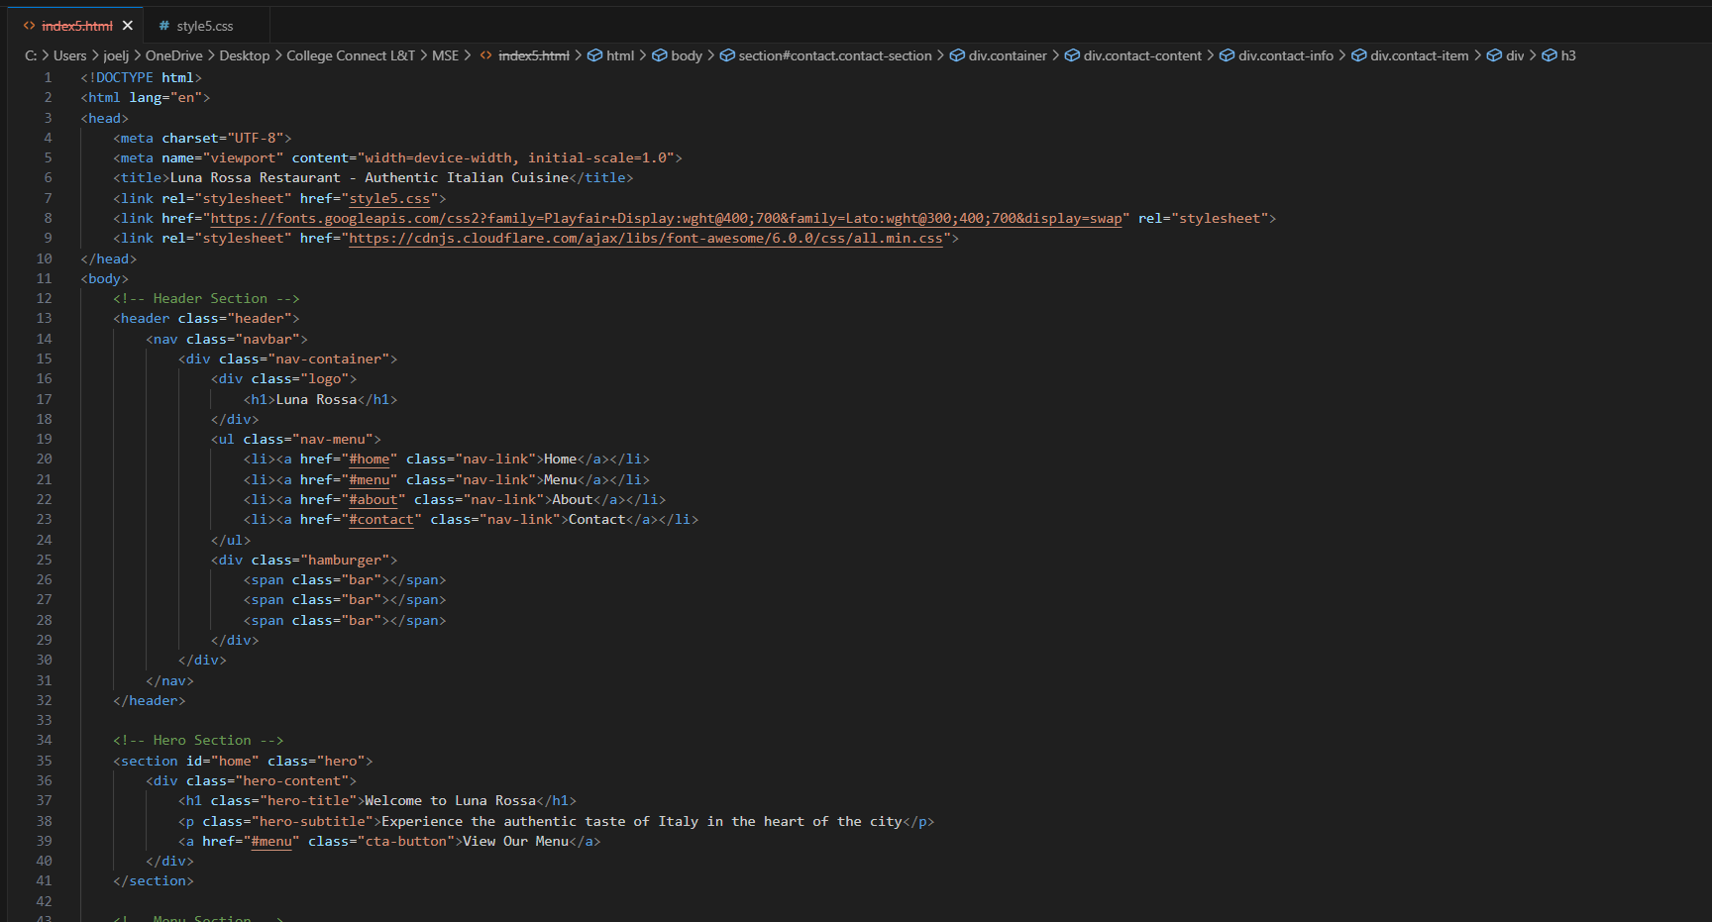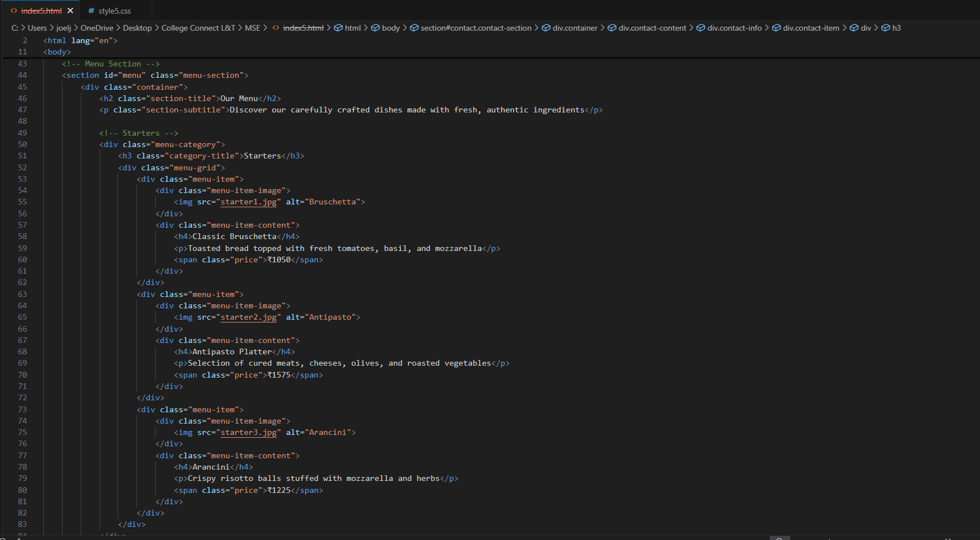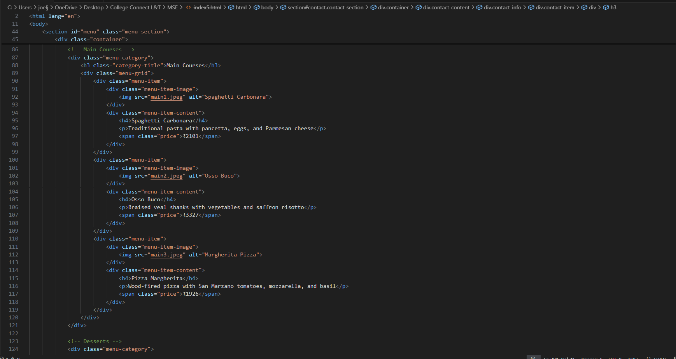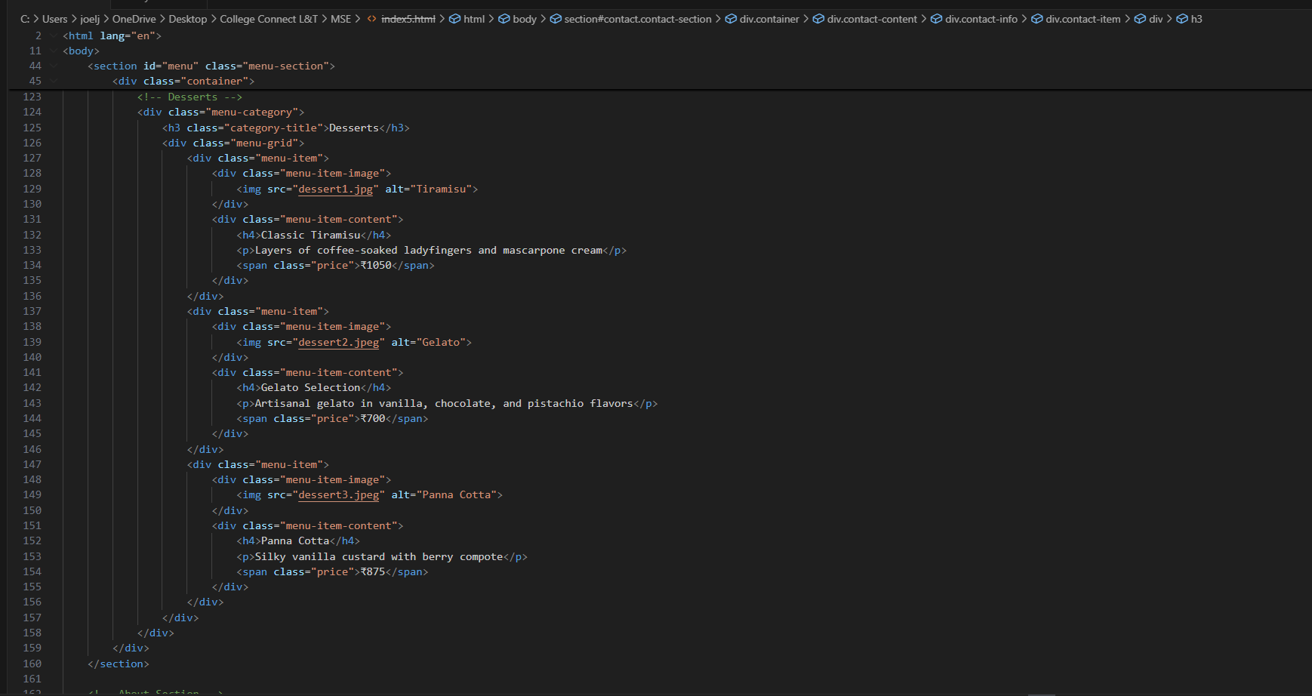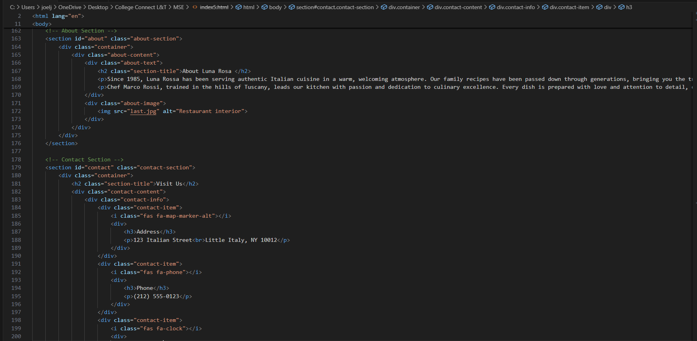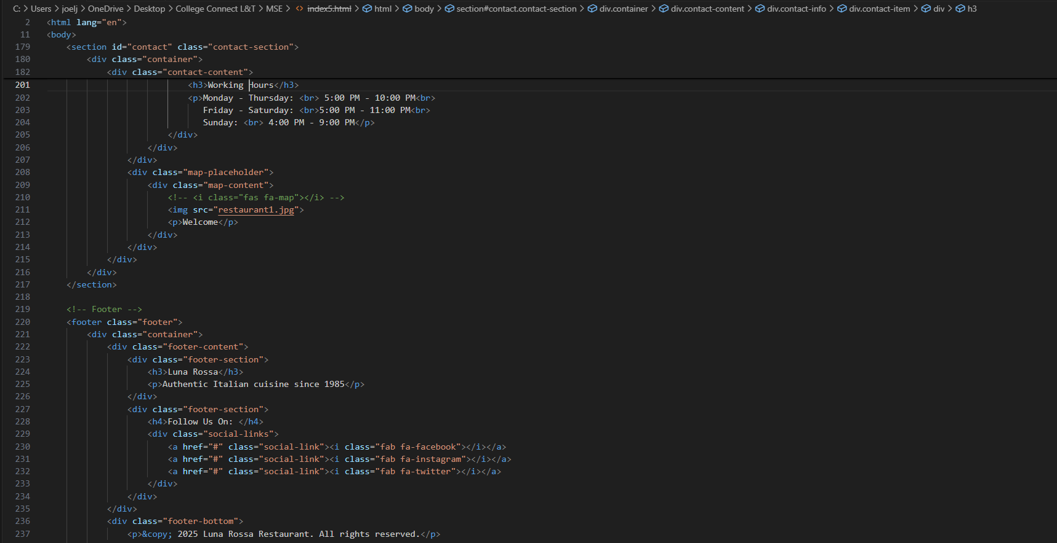

- CSS code:

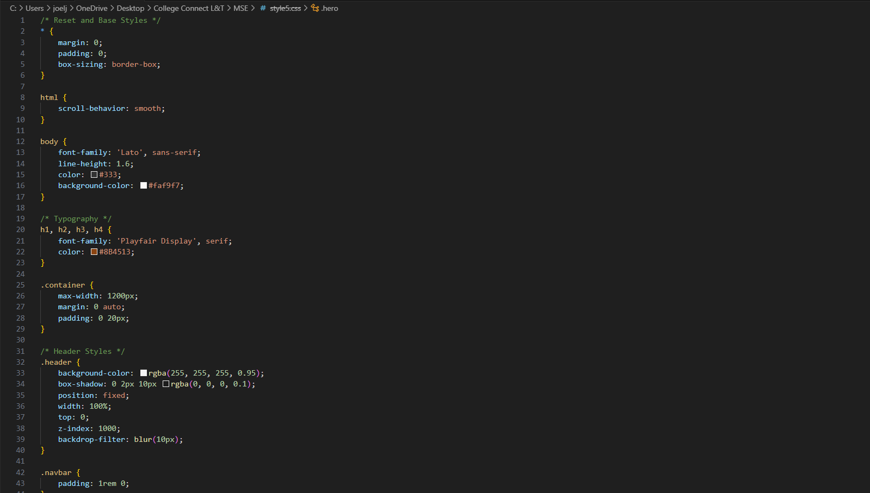
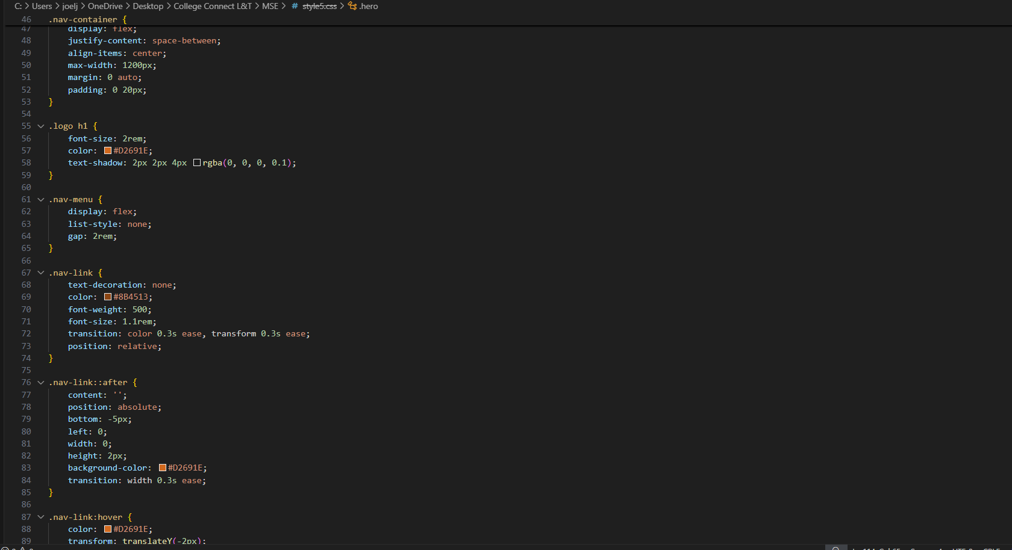
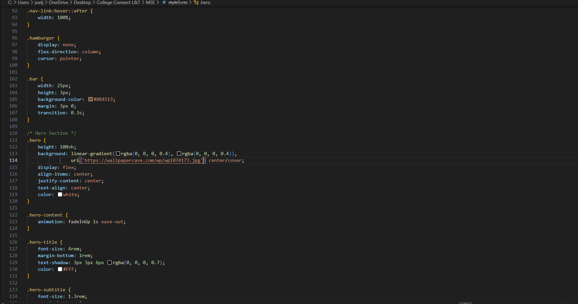
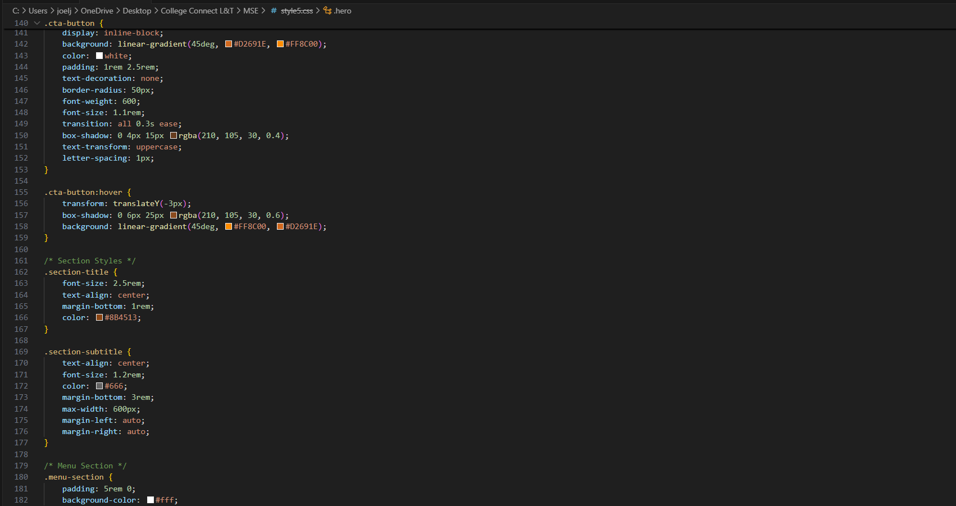
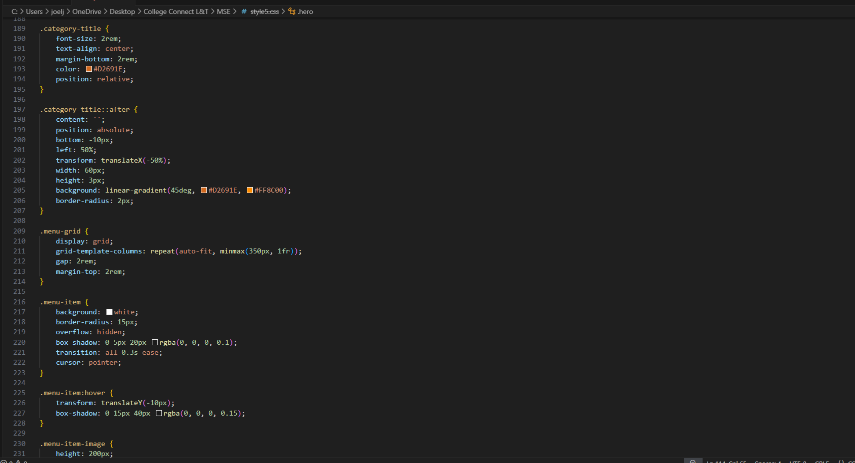
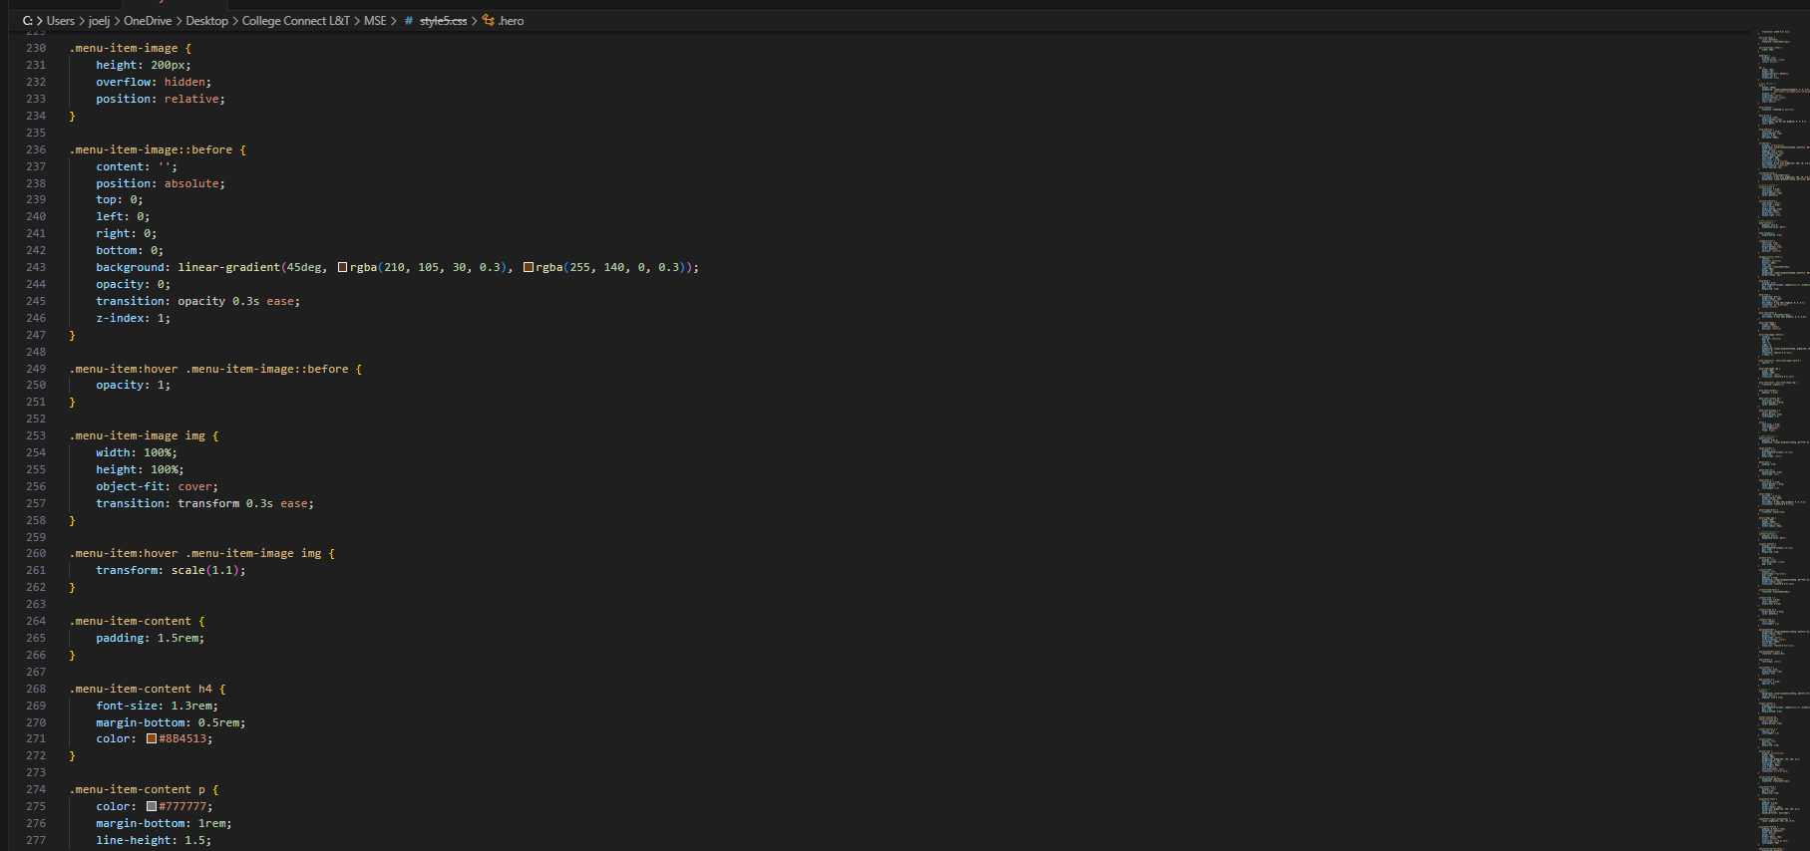
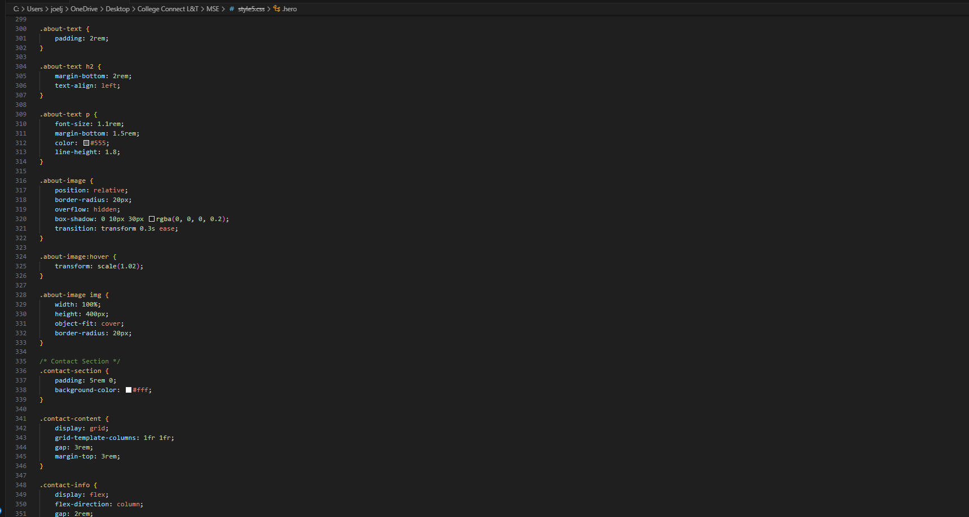
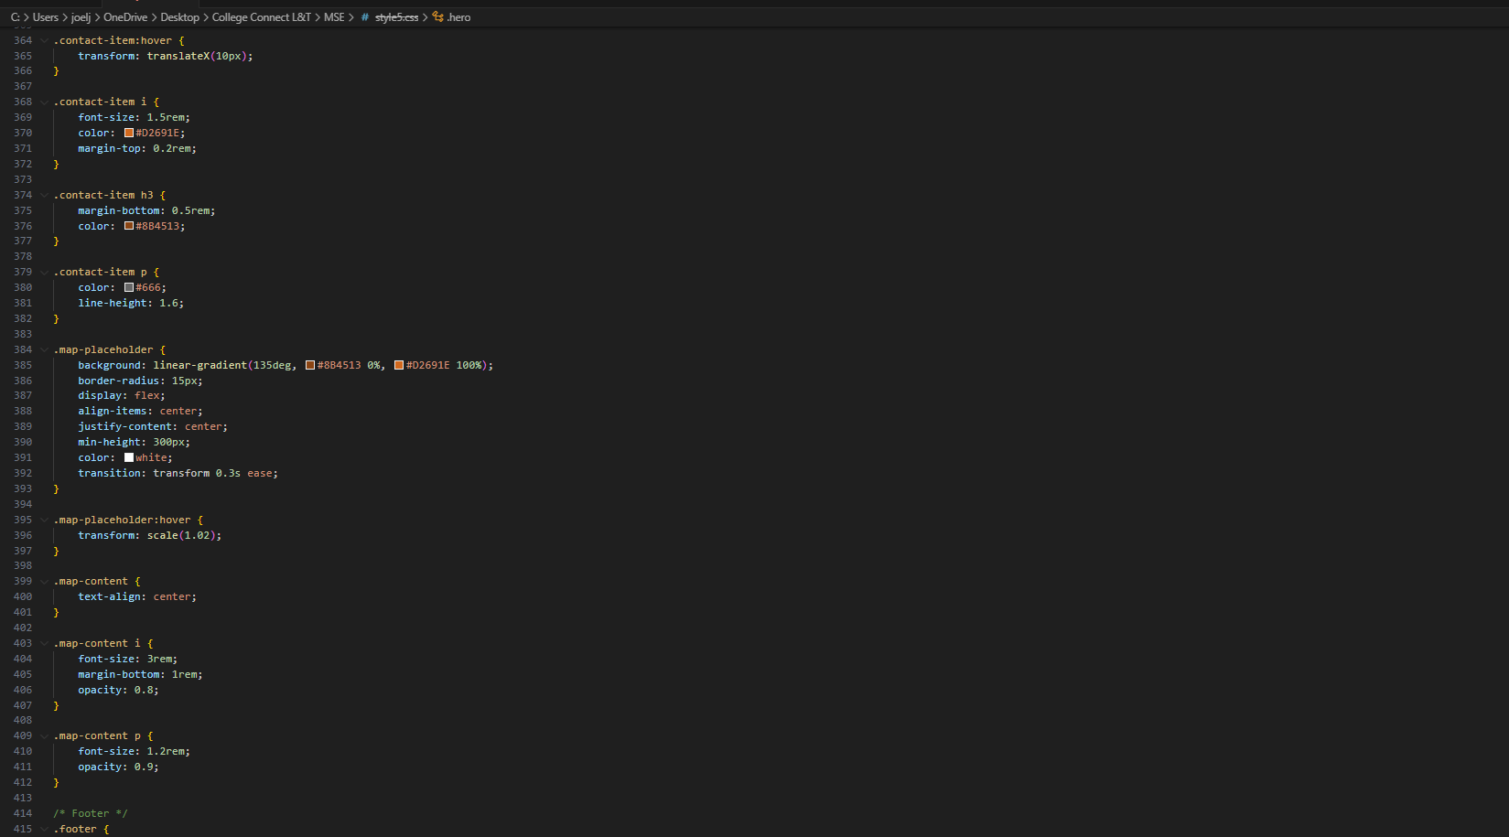
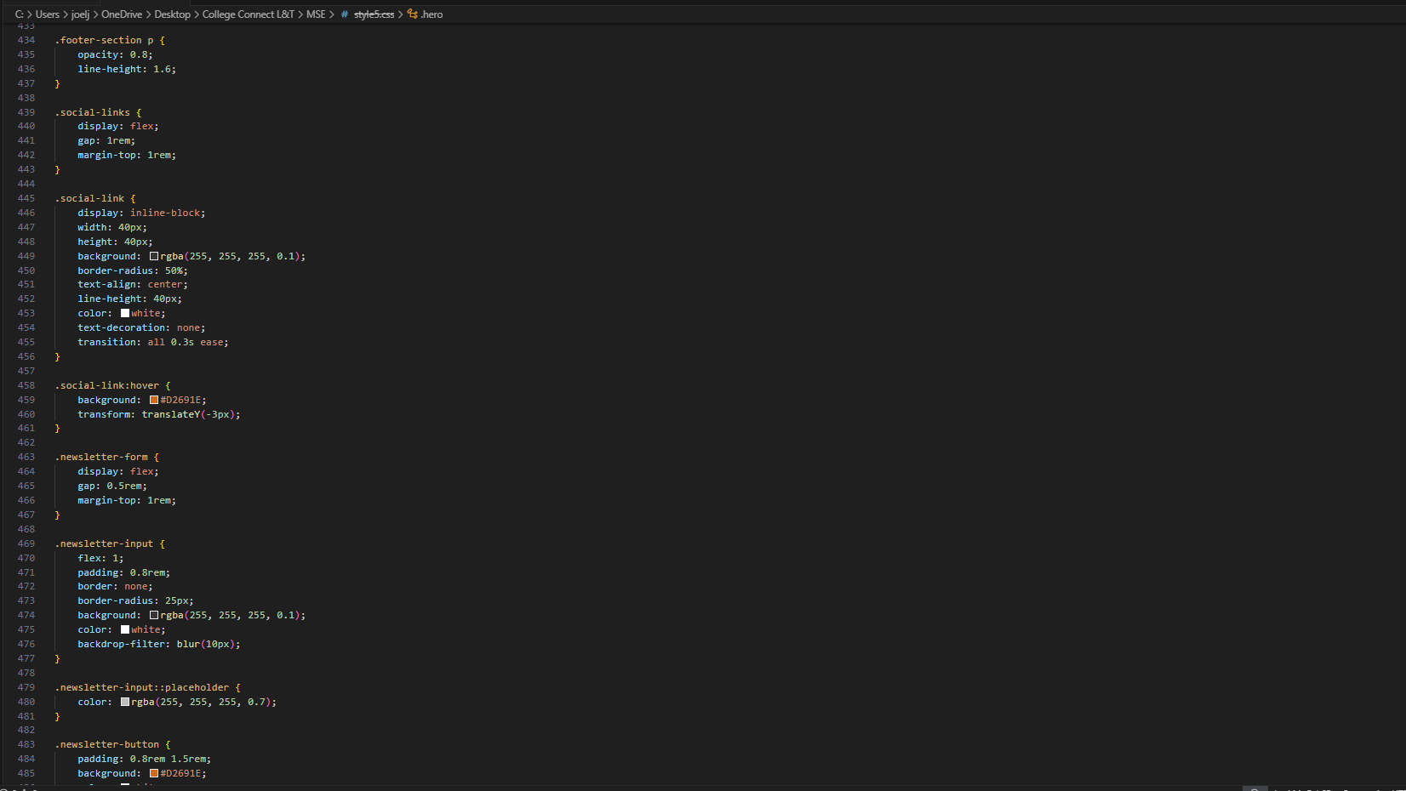
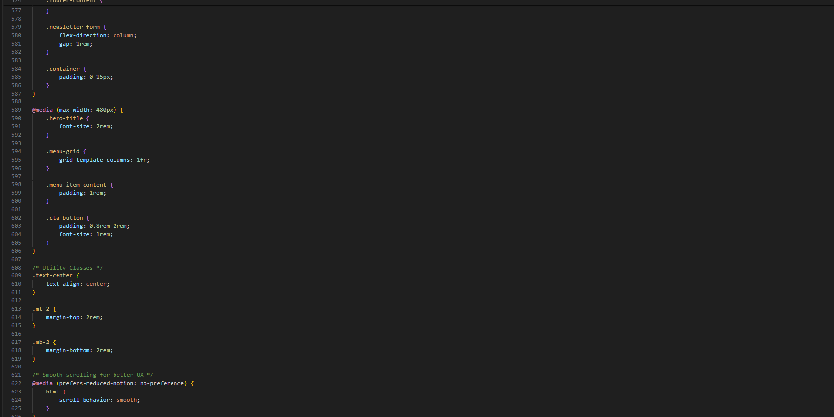

13. Screenshots of Final Output

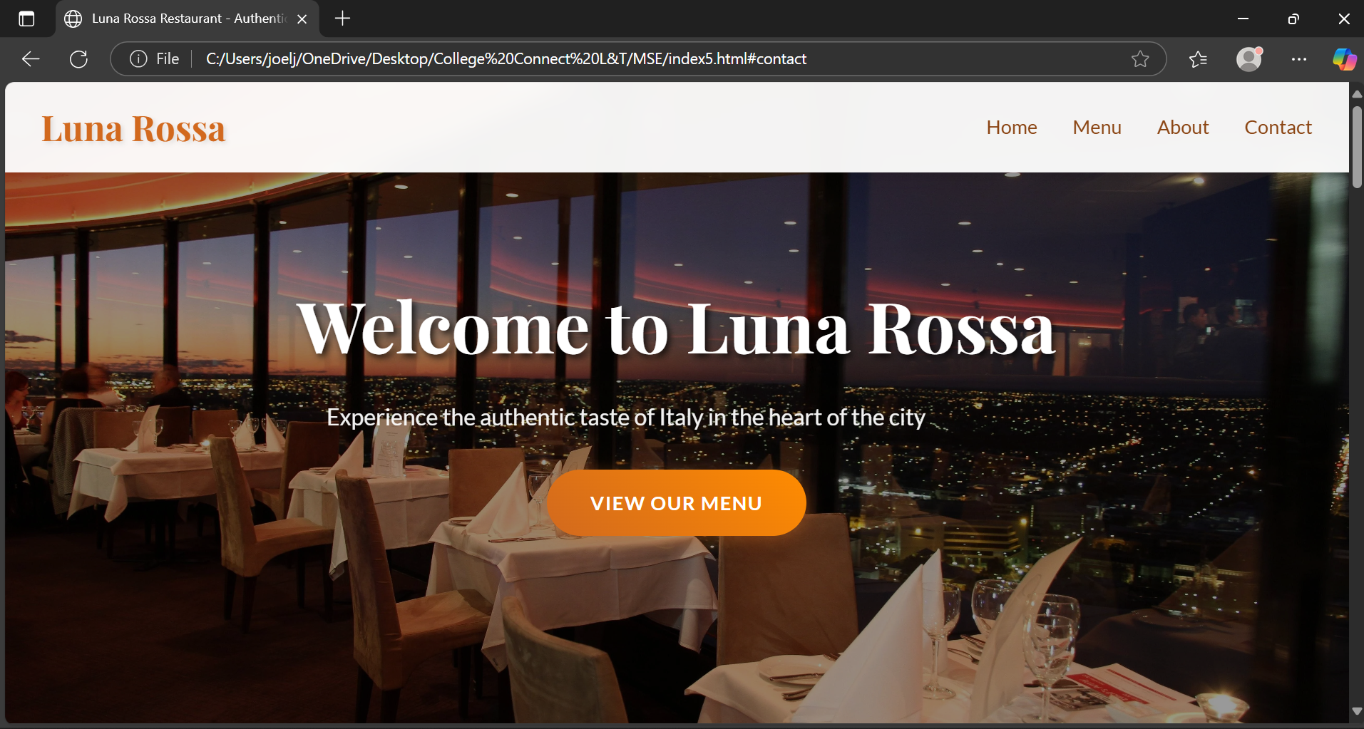
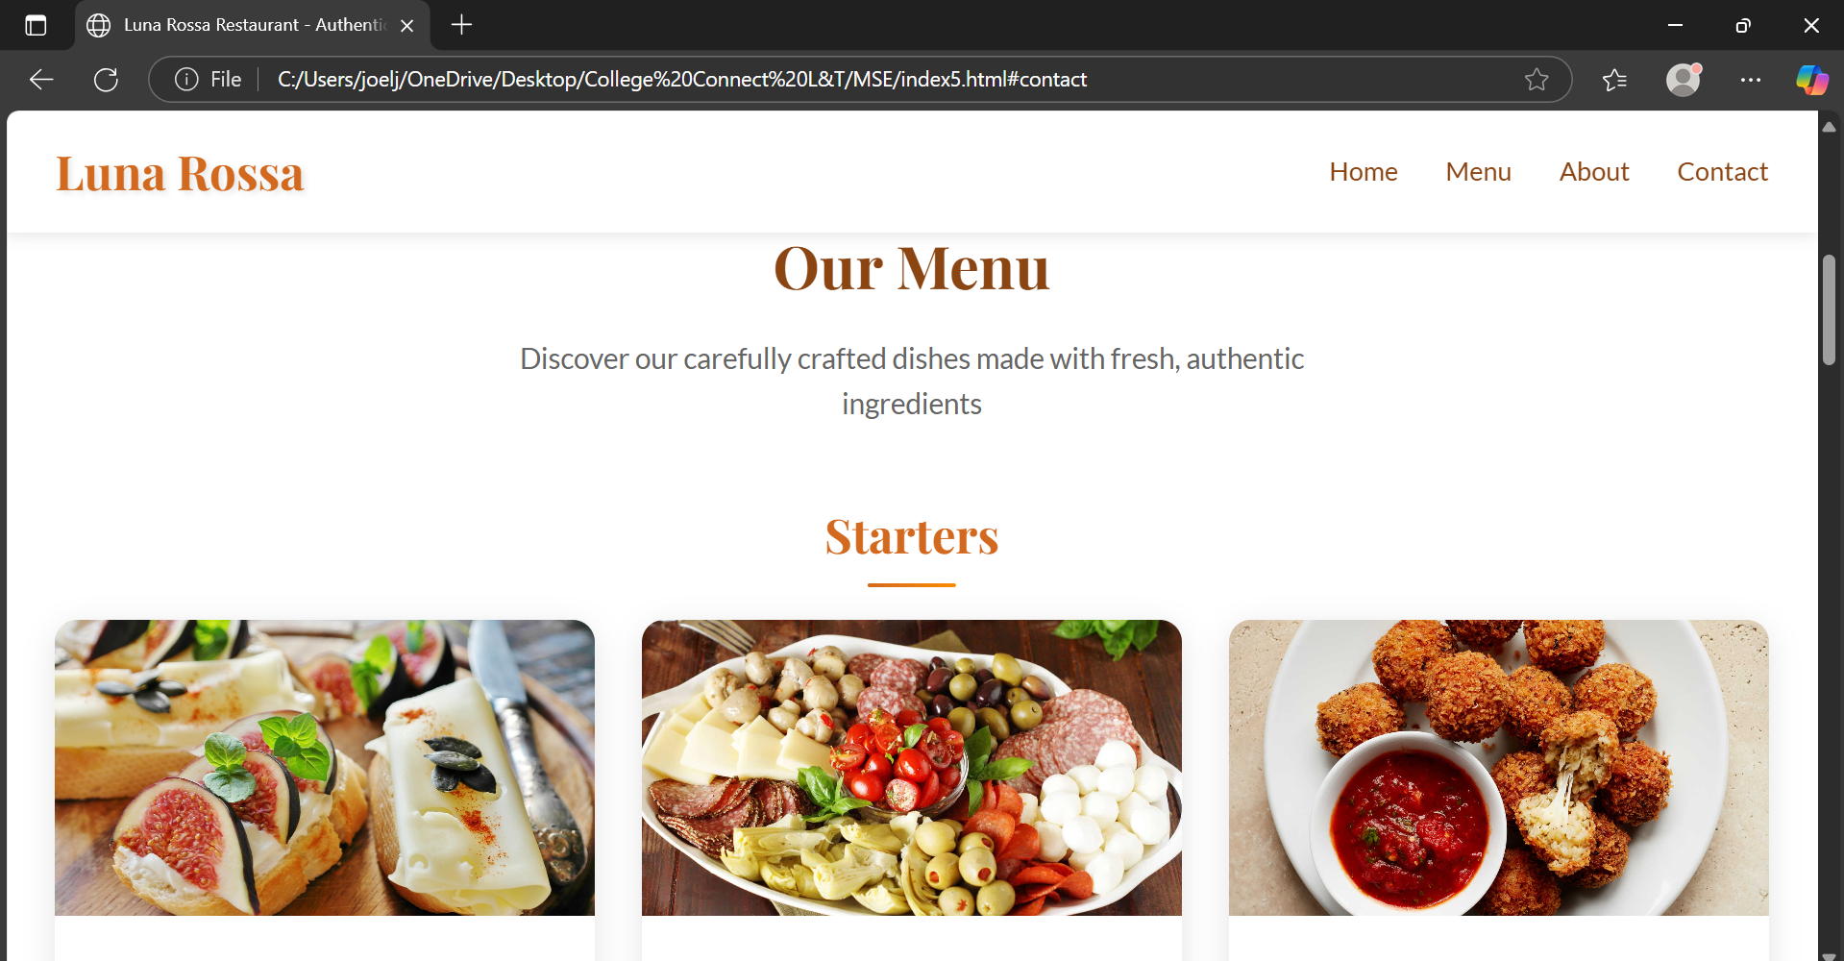
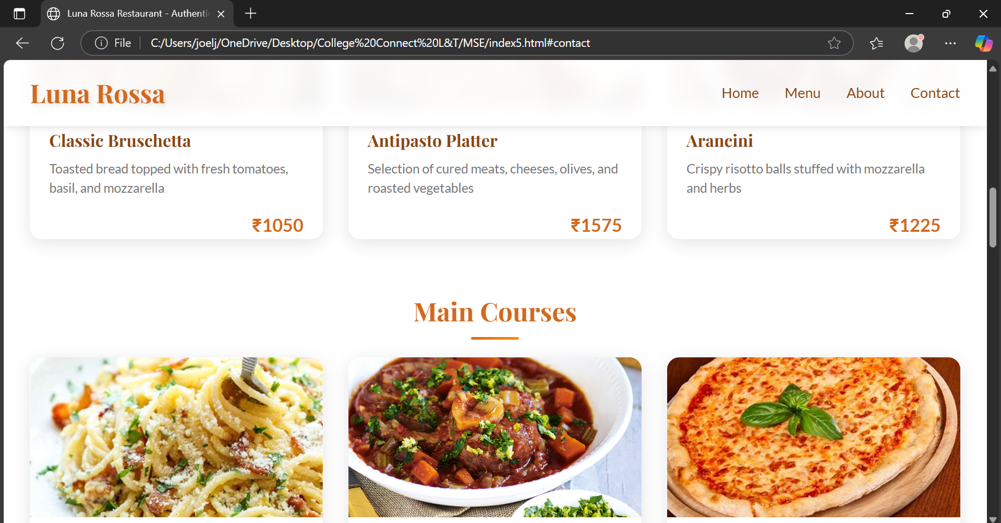
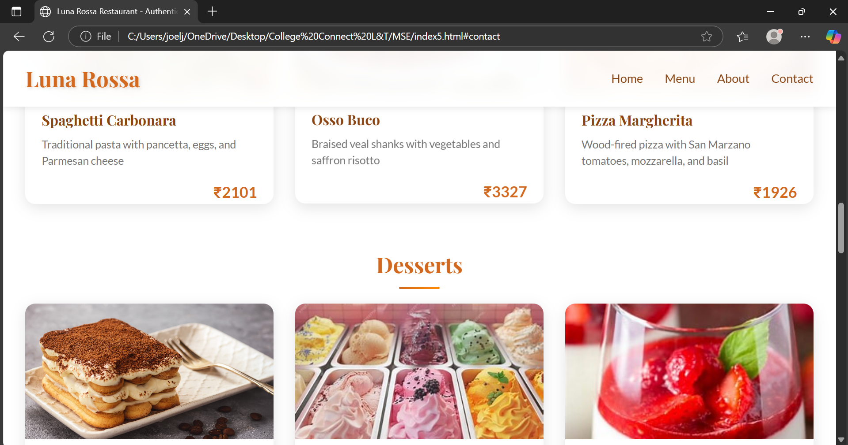
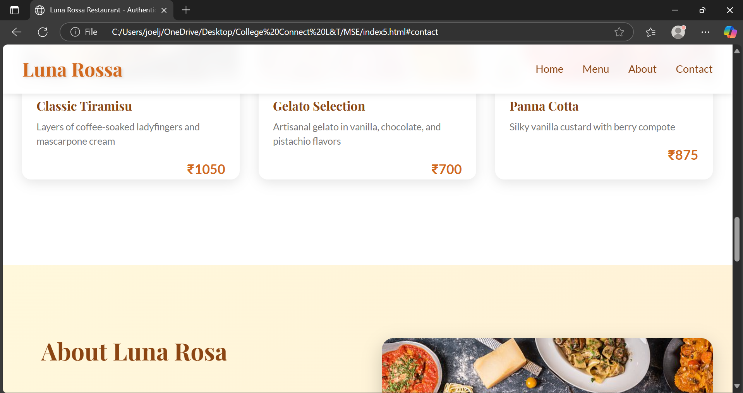
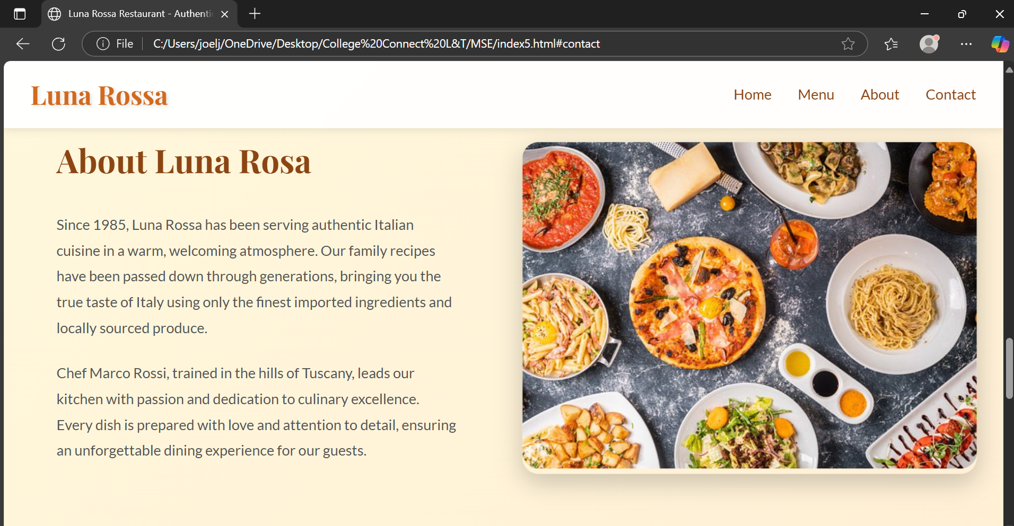
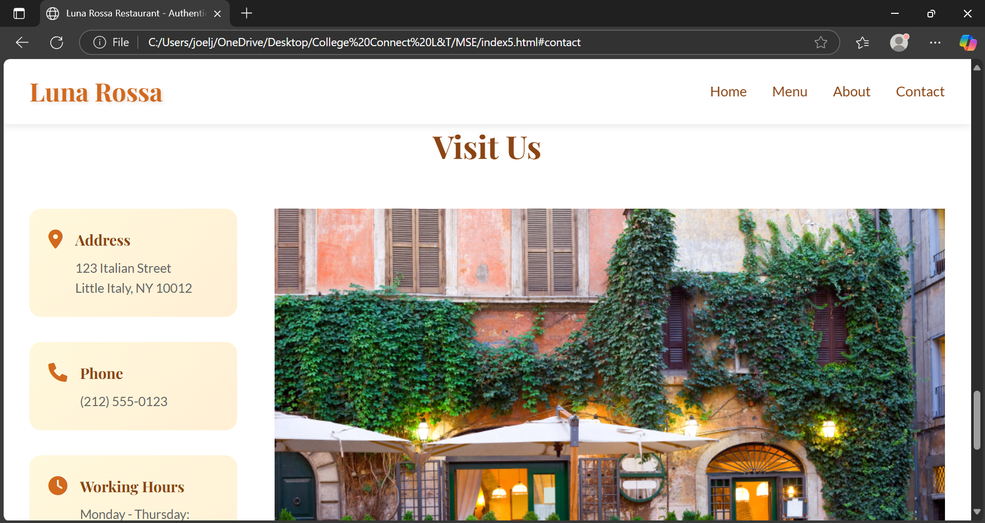
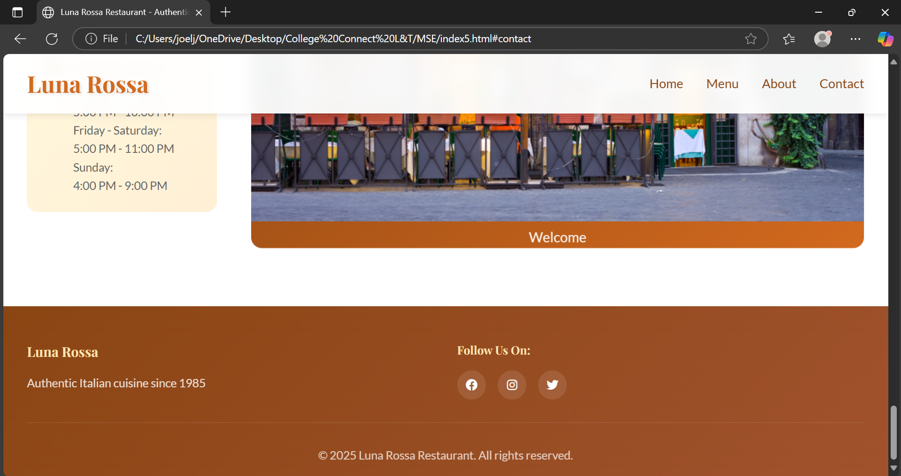

11. Conclusion
The Luna Rossa Restaurant website effectively combines simplicity, performance, and elegance to provide customers with an immersive browsing experience. Its responsive layout, warm design, and structured content make it a valuable digital presence for the restaurant, while the pure HTML & CSS approach ensures high compatibility and low maintenance costs.

12. References
- L&T LMS : https://learn.lntedutech.com/Landing/MyCourse

